**Review Application Design Deliverables**

**Module Description**

In this module, your team is given access to a set of project analysis and design documents to review so you can prepare for the build effort. You will have time to ask the managers (Faculty) questions and discuss the project amongst your team.

**Participant Presentation**

Click the link to launch the [Module 29 Presentation](https://accenture.desire2learn.com/content/enforced/9406-Pending/W3_Participant_Materials/Module_29/ADF_2_0_Java_M29_TimeWarp_PD.pptx?_&d2lSessionVal=YnoL4daZGC8ne2RyGf0cWMrk8).

**Scenario**

As part of ADM Task 3193 (Start Application Build to Verify Readiness), the Developer SMEs are currently identifying and fixing gaps in the Design deliverables by creating detailed pseudo-code, application code and unit test deliverables (Test Conditions and Expected Results, Test Scenarios, Test Cycle Control Sheet and Test Scripts). By tracking the time it takes to complete their activities, the SMEs are assessing if the initial time estimates to perform the build activities are accurate. Some of the estimates for the build activities are adjusted.

Now that you have completed the project orientation, you are ready to review the Analysis and Design documents that were created earlier in the project. You need to get comfortable with these work products and understand how they will help you to:

* Create the unit test cases.
* Create the unit test scripts.
* Implement the logic in the class methods.

**ADM Activity Context Diagram**

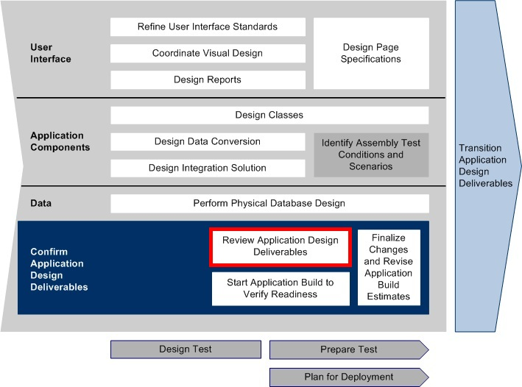

**Roles**

|  |  |  |  |
| --- | --- | --- | --- |
| **Role** | **ADM Task** | **ADM Responsibility** | **Description** |
| Team Lead | 4183 - Create Unit Tests | Primary Performer | Tracks the status and performance of the Peer Reviews. |

**Participant Instructions**

1. Ensure that one (or more) members of the team download a copy of the [Query Log](https://accenture.desire2learn.com/content/enforced/9406-Pending/NCCC_Project_Work_Products/1_PM/Release_1/QueryLog_FERS_R1_TMPL.xlsx?_&d2lSessionVal=YnoL4daZGC8ne2RyGf0cWMrk8) and save a copy as QueryLog_FERS_R1_<>.docx.

**Please Note:** The purpose of the Query Log is to document general questions that you have about the documents. You are not reviewing these documents looking for issues (checking consistency and correctness). You are reviewing these for clarity and understanding of the information the documents provide and the project scope overall.

2. Review the project’s work products from the Analysis stage. Document any questions that you have in the Query Log.

**Please Note:** You are not being asked to critique or perform quality assurance tests on the documents. The query log is for you to record any questions you have about the information contained in the design docs.

Documents from the Analysis stage:

a. [AP201 Requirements and Traceability](https://accenture.desire2learn.com/content/enforced/9406-Pending/NCCC_Project_Work_Products/3a_App_Analysis/Release_1/RTM_FERS_R1_REF.xlsx?_&d2lSessionVal=YnoL4daZGC8ne2RyGf0cWMrk8)

b. AP212 Use Case

|  |  |
| --- | --- |
|  | ο [Use Case UC1](https://accenture.desire2learn.com/content/enforced/9406-Pending/NCCC_Project_Work_Products/3a_App_Analysis/Release_1/UseCase_FERS_UC1_RegisterVisitor_R1_REF.docx?_&d2lSessionVal=YnoL4daZGC8ne2RyGf0cWMrk8) (Register Visitor) |
|  | ο [Use Case UC2](https://accenture.desire2learn.com/content/enforced/9406-Pending/NCCC_Project_Work_Products/3a_App_Analysis/Release_1/UseCase_FERS_UC2_LoginVisitor_R1_REF.docx?_&d2lSessionVal=YnoL4daZGC8ne2RyGf0cWMrk8) (Log In Visitor) |
|  | ο [Use Case UC3](https://accenture.desire2learn.com/content/enforced/9406-Pending/NCCC_Project_Work_Products/3a_App_Analysis/Release_1/UseCase_FERS_UC3_UpdateVisitor_R1_REF.docx?_&d2lSessionVal=YnoL4daZGC8ne2RyGf0cWMrk8) (Update Visitor) |
|  | ο [Use Case UC4](https://accenture.desire2learn.com/content/enforced/9406-Pending/NCCC_Project_Work_Products/3a_App_Analysis/Release_1/UseCase_FERS_UC4_RegisterForEvent_R1_REF.docx?_&d2lSessionVal=YnoL4daZGC8ne2RyGf0cWMrk8) (Register for Event) |
|  | ο [Use Case UC5](https://accenture.desire2learn.com/content/enforced/9406-Pending/NCCC_Project_Work_Products/3a_App_Analysis/Release_1/UseCase_FERS_UC5_UnregisterFromEvent_R1_REF.docx?_&d2lSessionVal=YnoL4daZGC8ne2RyGf0cWMrk8) (Unregister for Event) |
|  | ο [Use Case Diagram](https://accenture.desire2learn.com/content/enforced/9406-Pending/NCCC_Project_Work_Products/3a_App_Analysis/Release_1/UseCaseDiag_FERS_R1_REF.docx?_&d2lSessionVal=YnoL4daZGC8ne2RyGf0cWMrk8) |

c. [AP213 Business Rules](https://accenture.desire2learn.com/content/enforced/9406-Pending/NCCC_Project_Work_Products/3a_App_Analysis/Release_1/BusRules_FERS_R1_REF.docx?_&d2lSessionVal=YnoL4daZGC8ne2RyGf0cWMrk8)

d. [AP214 Data Dictionary](https://accenture.desire2learn.com/content/enforced/9406-Pending/NCCC_Project_Work_Products/3a_App_Analysis/Release_1/DataDict_FERS_R1_REF.docx?_&d2lSessionVal=YnoL4daZGC8ne2RyGf0cWMrk8)

e. [AP235 Personas](https://accenture.desire2learn.com/content/enforced/9406-Pending/NCCC_Project_Work_Products/3a_App_Analysis/Release_1/Personas_FERS_R1_REF.docx?_&d2lSessionVal=YnoL4daZGC8ne2RyGf0cWMrk8)

f. [AP242 Site Map](https://accenture.desire2learn.com/content/enforced/9406-Pending/NCCC_Project_Work_Products/3a_App_Analysis/Release_1/SiteMap_FERS_R1_REF.docx?_&d2lSessionVal=YnoL4daZGC8ne2RyGf0cWMrk8)

3. Review the project’s work products from the Design stage. Document any questions that you have in the Query Log.

Documents from the Design stage:

a. [AP331 Domain Class Model](https://accenture.desire2learn.com/content/enforced/9406-Pending/NCCC_Project_Work_Products/3b_App_Design/Release_1/DomClsMdl_FERS_R1_REF.docx?_&d2lSessionVal=YnoL4daZGC8ne2RyGf0cWMrk8)

b. [AP333 Component/Class Design](https://accenture.desire2learn.com/content/enforced/9406-Pending/NCCC_Project_Work_Products/3b_App_Design/Release_1/CompClsDes_FERS_R1_WOPC_REF.docx?_&d2lSessionVal=YnoL4daZGC8ne2RyGf0cWMrk8) (w/o pseudo-code)

c. WP334 Interaction Diagram

|  |  |
| --- | --- |
|  | ο [Interaction Diagram UC1](https://accenture.desire2learn.com/content/enforced/9406-Pending/NCCC_Project_Work_Products/3b_App_Design/Release_1/IntDiag_FERS_UC1_RegisterVisitor_R1_REF.vsd?_&d2lSessionVal=YnoL4daZGC8ne2RyGf0cWMrk8) (Register Visitor) |
|  | ο [Interaction Diagram UC2](https://accenture.desire2learn.com/content/enforced/9406-Pending/NCCC_Project_Work_Products/3b_App_Design/Release_1/IntDiag_FERS_UC2_LoginVisitor_R1_REF.vsd?_&d2lSessionVal=YnoL4daZGC8ne2RyGf0cWMrk8) (Log In Visitor) |
|  | ο [Interaction Diagram UC3](https://accenture.desire2learn.com/content/enforced/9406-Pending/NCCC_Project_Work_Products/3b_App_Design/Release_1/IntDiag_FERS_UC3_UpdateVisitor_R1_REF.vsd?_&d2lSessionVal=YnoL4daZGC8ne2RyGf0cWMrk8) (Update Vistor) |
|  | ο [Interaction Diagram UC4](https://accenture.desire2learn.com/content/enforced/9406-Pending/NCCC_Project_Work_Products/3b_App_Design/Release_1/IntDiag_FERS_UC4_RegisterforEvent_R1_REF.vsd?_&d2lSessionVal=YnoL4daZGC8ne2RyGf0cWMrk8) (Register for Event) |
|  | ο [Interaction Diagram UC5](https://accenture.desire2learn.com/content/enforced/9406-Pending/NCCC_Project_Work_Products/3b_App_Design/Release_1/IntDiag_FERS_UC5_UnregisterFromEvent_R1_REF.vsd?_&d2lSessionVal=YnoL4daZGC8ne2RyGf0cWMrk8) (Unregister for Event) |

d. [WP344 Wireframe](https://accenture.desire2learn.com/content/enforced/9406-Pending/NCCC_Project_Work_Products/3b_App_Design/Release_1/Wireframe_FERS_R1_REF.docx?_&d2lSessionVal=YnoL4daZGC8ne2RyGf0cWMrk8)

4. In line with project standards, quickly review the [MG289 Entry/Exit Criteria](https://accenture.desire2learn.com/content/enforced/9406-Pending/NCCC_Project_Work_Products/1_PM/Release_1/ExtEntCrit_FERS_R1_REF.xlsx?_&d2lSessionVal=YnoL4daZGC8ne2RyGf0cWMrk8) document to understand the checklists that must be completed to move to the next stage of the project.

5. As a team, discuss the documents and the questions you gathered with each other. Make sure the team is comfortable with:

a. What information and details each document provides.

b. How each document supports, and is consistent with, the other related documents (e.g., the design work products provide more details about what is described in the analysis work products).

c. How each document helps to describe the application that will be implemented.

d. Where each document appears in the AP201 Requirements and Traceability Matrix.

6. As questions are answered, document the answers in the Query Log. Store the file as required by the Management.

7. When a manager or the Developer SME comes to your desk, take the opportunity to get answers to your unanswered questions.

**Hints and Tips**

1. Start with the Analysis Deliverables first to get a high-level perspective on what the system will do before looking at the design deliverables explaining 'how' it will be implemented.

2. Ensure you understand what information is provided in each work product and how it supports the development of the code.

Some documents focus on the data, some describe events that trigger actions or processes and some detail the process themselves.

3. Ensure you are very conscious of the manager's or Developer SME's time and only ask questions that the team is unable to determine.